Appendix 4 Quantitative results data

Table 1.Five Facet Mindfulness Questionnaire. See:
https://ggsc.berkeley.edu/images/uploads/Five_Facet_Mindfulness_Questionnaire.pdf
Measure | Mean Score at Start (Standard Deviation) | Mean Score at End | Clinical Change | Significant Change
Non Judging (n=14) | 15  (3.419) | 14.5  (4.274) | On average, there was a small decrease in Non judging scores, however this was not found to be significant, t(13)=0.676, p=0.511 | No.
Observing (n=14) | 14.86  (2.316) | 17  (2.418) | On average, Observing scores increased significantly,  t(13)=-3.198, p=0.007 | Yes.
Act with Awareness (n=14) | 14.5  (3.737) | 16.14  (3.697) | On average, Acting with Awareness scores increased significantly, t(13)=-2.248 p=0.043 | Yes.
Describing (n=14) | 15.93  (4.779) | 17.07  (3.832) | On average, Describing scores increased however this was not found to be significant, t(13)=--1.343, p=0.202 | No.
Non-reactive  (n=14) | 13.71  (4.34) | 16  (2.855) | On average, Non Reactivity scores increased significantly, t(13)=-2.760, p=0.016 | Yes.

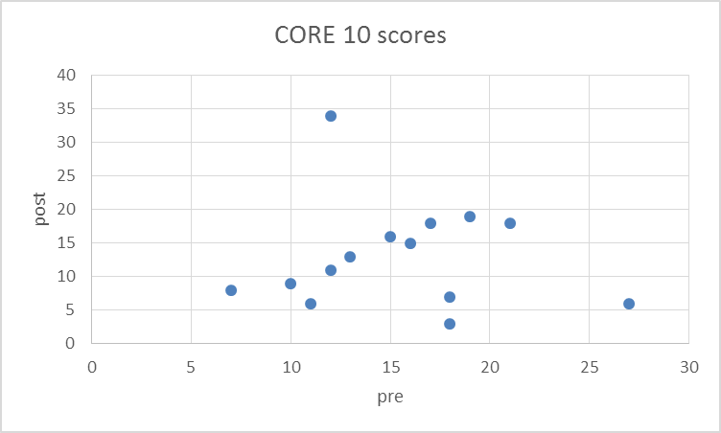

Graph 1: CORE 10 outcome measures, pre and post group

